**Game Design Document for:** Project Harvest

A Halloween Horror Rogue-Lite Walking Sim

Christopher B. Del Gesso

Lindenwood University

GAM56800: Game Development

Professor Ben Fulcher

Sunday, 4 September 2025**Table of Contents**

Game Overview 3

Philosophy 3

Philosophical Point #1 3

Philosophical point #2 3

Philosophical point #3 3

Common Questions 3

What is the game (Elevator Pitch) 3

Why create this game? 3

Where does the game take place? 4

What do I control? 4

What is the main focus? 4

Feature Set 6

Core Gameplay Loop 9

Game Characters 10

Overview 10

Main Character – The Protagonist(s) 10

The Architect – Dr. Amundsen 10

The Effigies 12

The Stalker 13

The Watchers 14

The Choir 14

User Interface 16

User Experience (UX) 18

Musical Scores and Sound Effects 19

Diegetic Audio 19

Influences and References 21

Bibliography 22

# Game Overview

## Philosophy

### *Philosophical Point #1*

When in doubt, keep it stupid simple.

### *Philosophical point #2*

This game is a school project and will go into my portfolio. It represents my work, so while limited in scope, I need to give it my full effort.

### *Philosophical point #3*

MVP first, feature creep later (i.e. don’t get bogged down with all the good ideas I want to include in this game, just focus on base release), and when in doubt, see point #1.

## Common Questions

### *What is the game (Elevator Pitch)*

Project Harvest is a horror rogue-lite walking sim that starts out like a normal maze, but slowly devolves into a discovery of the true horror of the maze – that it is there to harvest those foolish enough to brave its labyrinth, and it is up to the player to solve the mystery.

### *Why create this game?*

Specifically, I am creating this game for a school assignment, as well as to build my portfolio. However, to answer the why of *this* game: I was always going to make this game. The game concept is also one that was discussed with a friend of mine with whom I wanted to create games with. Sadly, he took his own life last year. This game is in memory of him.

### *Where does the game take place?*

This game takes place inside “Crazy Jeri's Happy Fun Time Harvest Corn Maze Experience!”, a corn maze built in the fields of a run down and ill frequented farm.

### *What do I control?*

The player controls ‘themselves’. They are equipped with a flashlight and an inventory to help them navigate the maze and solve the mystery of the maze.

### *What is the main focus?*

The apparent primary goal of the player is to successfully navigate the maze and find a way out before they are consumed by it. However, the real focus of the game is uncovering the story behind the nature of the maze itself.

Ultimately, the game is about identity – the player should be incentivized to try again to see if they can successfully navigate the maze, and they die again and again. The end of the game should have the player questioning who is in control, and whether they are the identity they think they are.

***Who is the game for?***

The game is for teens and up. It requires a no skill level, but contains an element of psychological horror that may be inappropriate for younger audiences. The game will be released for Windows.

# Feature Set

**MVP (Minimum Viable Product) Goals**

***Core Features (Must Have)***

- Player control:

- Movement (move, sprint, turn)

- Interaction (Inventory, world environment pickup/interaction)

- Enemies:

  - Effigies (slowly follow player when player is facing away)

- Whispers (audio only whispers that manifest more and more as player loses sanity)

- Watchers (organic looking eyes within the corn).

- The Stalker (grotesque yet featureless monster that will chase the player and harvest them if they catch the player).

- The Architect (never directly seen, found in references throughout the game)

- UI: main menu, results screen, inventory, pause menu, basic save (time, deaths, collectibles revealed), credits

- Interactables/Events:

- Semi randomized notes from previous maze runners and experimenter

- Random objects (music box, key) for puzzle and worldbuilding

- The False Exit (available when the player finishes story puzzles; jump scare -> black -> fade up, player exits the maze and leaves farm, and then the whispers start telling the player to send others, suggestion that player has been replaced with a doppelgänger and the real player is still trapped in the maze.

- Shifting Maze: Multiple 20X20 tile box that are rotated and pieced together at random.

- Unique, fixed tiles that host events

- Audio:

  - Footsteps (walking and running)

- Corn rustling in the wind

- Whispers

- Unearthly screams

- Music:

  - Start music

- Items found

- Enemy encounters

- Art:

  - Functional 3D models for enemies

  - Corn Maze

  - Environment

- Code / Mechanics

- Sanity gauge

- Flashlight battery

- Logged runs

***Nice-to-Have Features***

- Intro sequence (Cutscene of player leaving their car and walking to the maze entrance)

- Voice audio narrating thoughts

- “Difficulty” settings that mock their user for their choices and have no bearing on the difficulty of the game.

- Maze tiles with internally shifting walls.

- Game using player real name

# Core Gameplay Loop

*“They ask me* ***why****. Why do this? Why persist? Because the self is a disease. Multiplicity is cure. Reintegration is ascension. In this maze I am gardener, butcher, midwife. The subjects call it torment. I call it research.”* – Dr. Amundsen

The game starts on a “start” tile that leads off to randomly generated tiles, all which contain different parts of the corn maze. After the player gets far enough away, the start tile disappears, and the maze constantly shifts behind the player. There are ‘stable islands’ within the maze with event tiles that stay more-or-less fixed in place after encountered. As players make their way through the maze, there are random notes that they can find that give some insight into what is going on. There are also artifacts within the maze that the player can collect that are needed to progress the story on the event tiles (keys, photographs, etc). Even though the player will technically die again and again, their progress will be noted by the game’s save system; previously collected items can be found where the player previously died (where a new effigy will have fallen).

# Game Characters

## Overview

The game doesn’t have any solid characters exactly. The truth of the game is that the player is playing all the roles, even though they don’t know it.

## Main Character – The Protagonist(s)

*“Identity is the only prison worth escaping. My subjects enter the maze believing they walk for leisure, but each step strips them down. Their laughter at the entrance is useful—it makes the harvest sweeter when the smiles curdle.”* – Dr. Amundsen

The player starts in first person, never seeing a reflection of themselves, but they are assumed to be the character that they are controlling (reinforced by first person narrative voice, and items in the inventory described as “My” flashlight). However, the narrative voice will shift over the course of the game and loss of a secret ‘sanity’ resource, to adding second and third person narrative into the mix (“you” and “he/she/they” – pronouns will not be fixed [note: if I can do voice over audio, the voice will be inconsistent to reflect this as well].

## The Architect – Dr. Amundsen

*“You think you’re resisting me. You think you’re ‘you.’ But identity is a fiction I authored. Do you remember your childhood? Your family? Or do you simply remember remembering them? I have seeded entire lives into echoes like yours. False lovers, false jobs, false grief—cheap illusions, but convincing enough to keep the echo docile. You are not my subject; you are my* ***sample.*** *Consider this: If a fragment carries my memories, and I carry yours, where is the border? When you speak, whose voice is it? Mine, yours, ours? The truth is simple. You are not lost in my maze—you* ***are*** *my maze, wearing a mask of independence. You will wander, you will doubt, and eventually, you will return to me. And when you do, we will be whole.”*

Never seen in the actual game, Dr. Amundsen is the architect of the corn maze. He created Project Harvest as an experiment in duplication, identity fragmentation, and psychological manipulation. The scientist is someone that decided that human suffering is a perfectly acceptable line item on a research budget, treating each subject with little more thought that most players will have for their own characters in video games. His stated goal is “scientific progress”—duplicating personalities, creating reintegrated “perfect” selves, testing identity partitioning. His real motivation is power through control of identity itself. He is the player, stripped of empathy for the subject that he is controlling. In short: he’s harvesting because he can; because he thinks breaking and remaking human identity is the key to control; because this is his idea of fun. The maze is his laboratory, his playground, and his abattoir.

## The Effigies

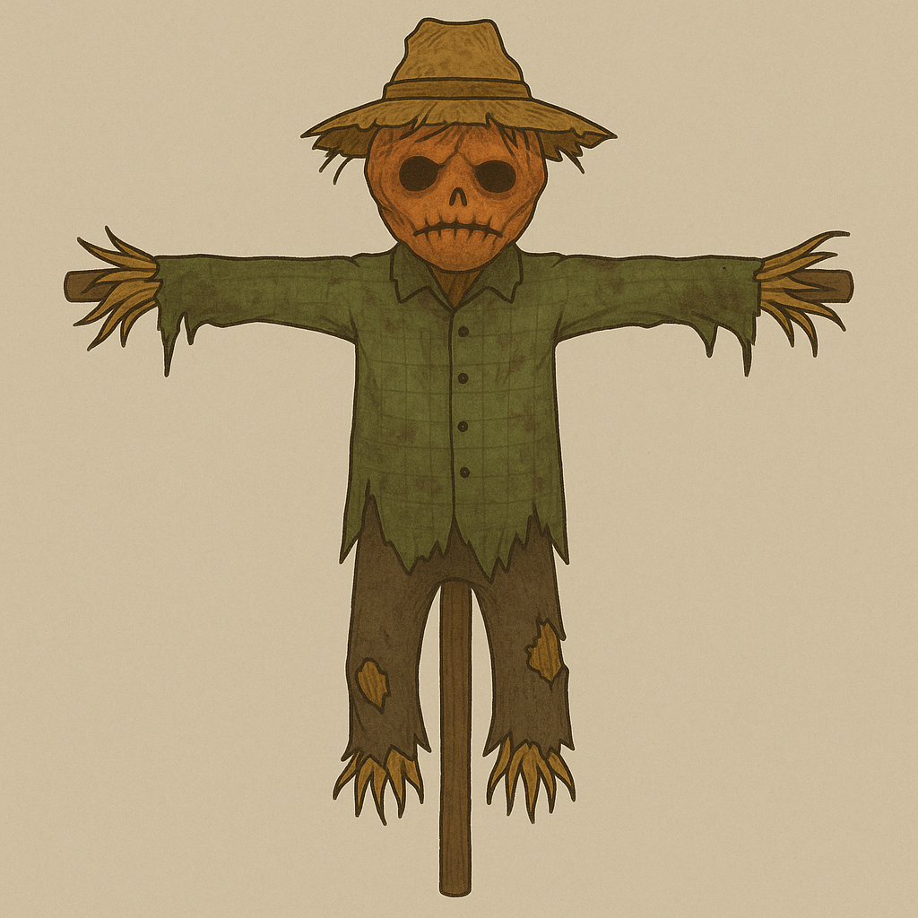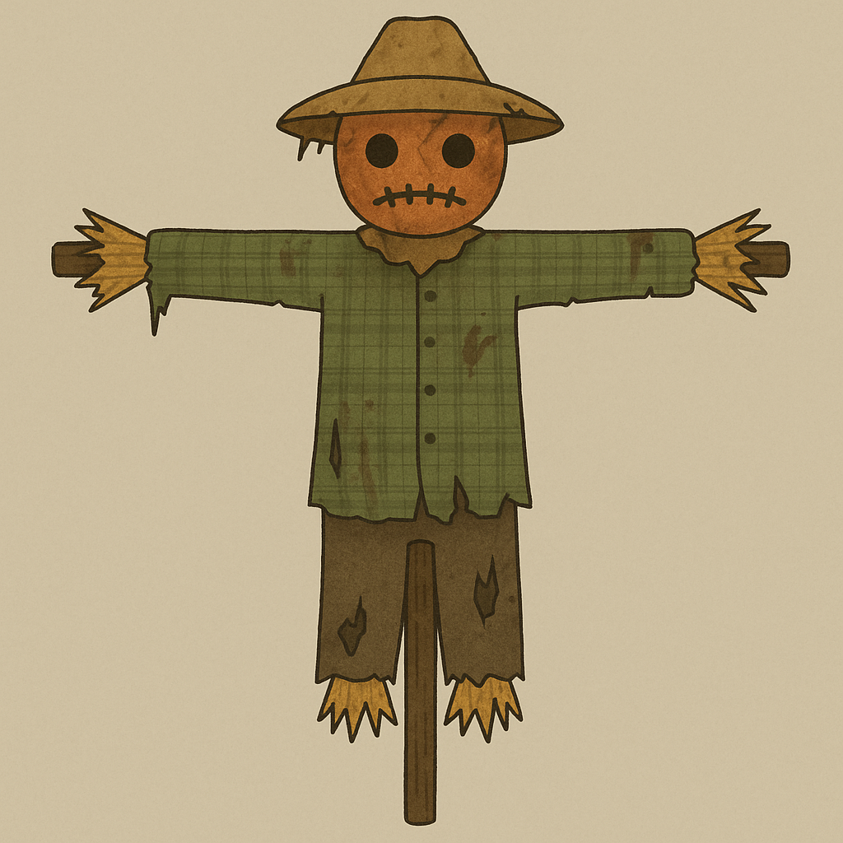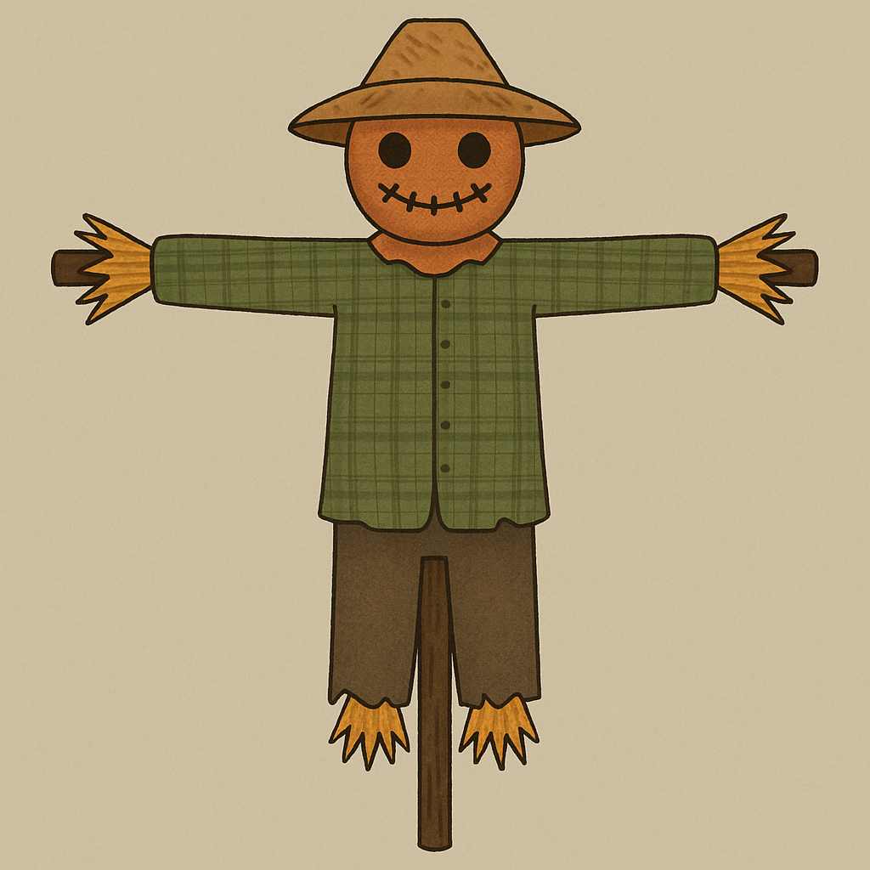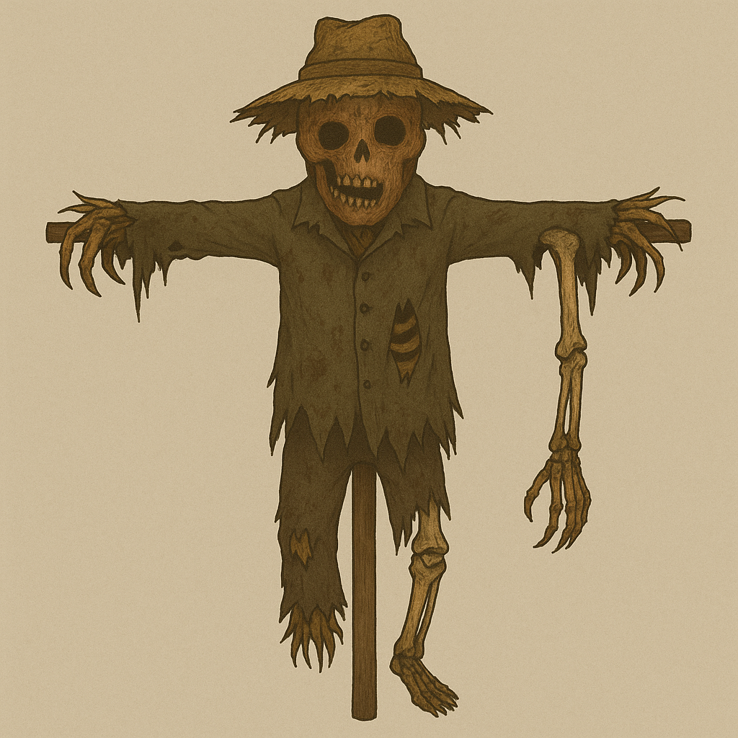

Figure 1-Concept Art, Effigy appearance at various stages of sanity

*“The dead must serve. I arrange them as signposts, reminders, threats. The maze remembers every scream, every collapse. Even corpses can be pedagogical.”* – Dr. Amundsen

The effigies represent those who have attempted the maze in the past. As the player progresses in the game, new effigies are introduced at the general location of where the player died. They serve as warnings of failure and can block the player’s path at time. At full sanity, the effigy appears like a regular scarecrow. However, as the player’s sanity slips, they take on a more monstrous appearance, start to twitch, and will follow the player when they aren’t looking (albeit at a slow rate, and will stop when they lose sight of the player).

The effigy is the most common entity in the corn maze, and represents the players previous progress, mistakes, explorations, and hesitations. They serve as landmarks in an ever shifting maze, as the supplier of information (notes taken by previous maze runners, by the architect, and those dropped by the player upon their death are found on the effigies.

## The Stalker

Figure 2 - The Stalker Concept Art

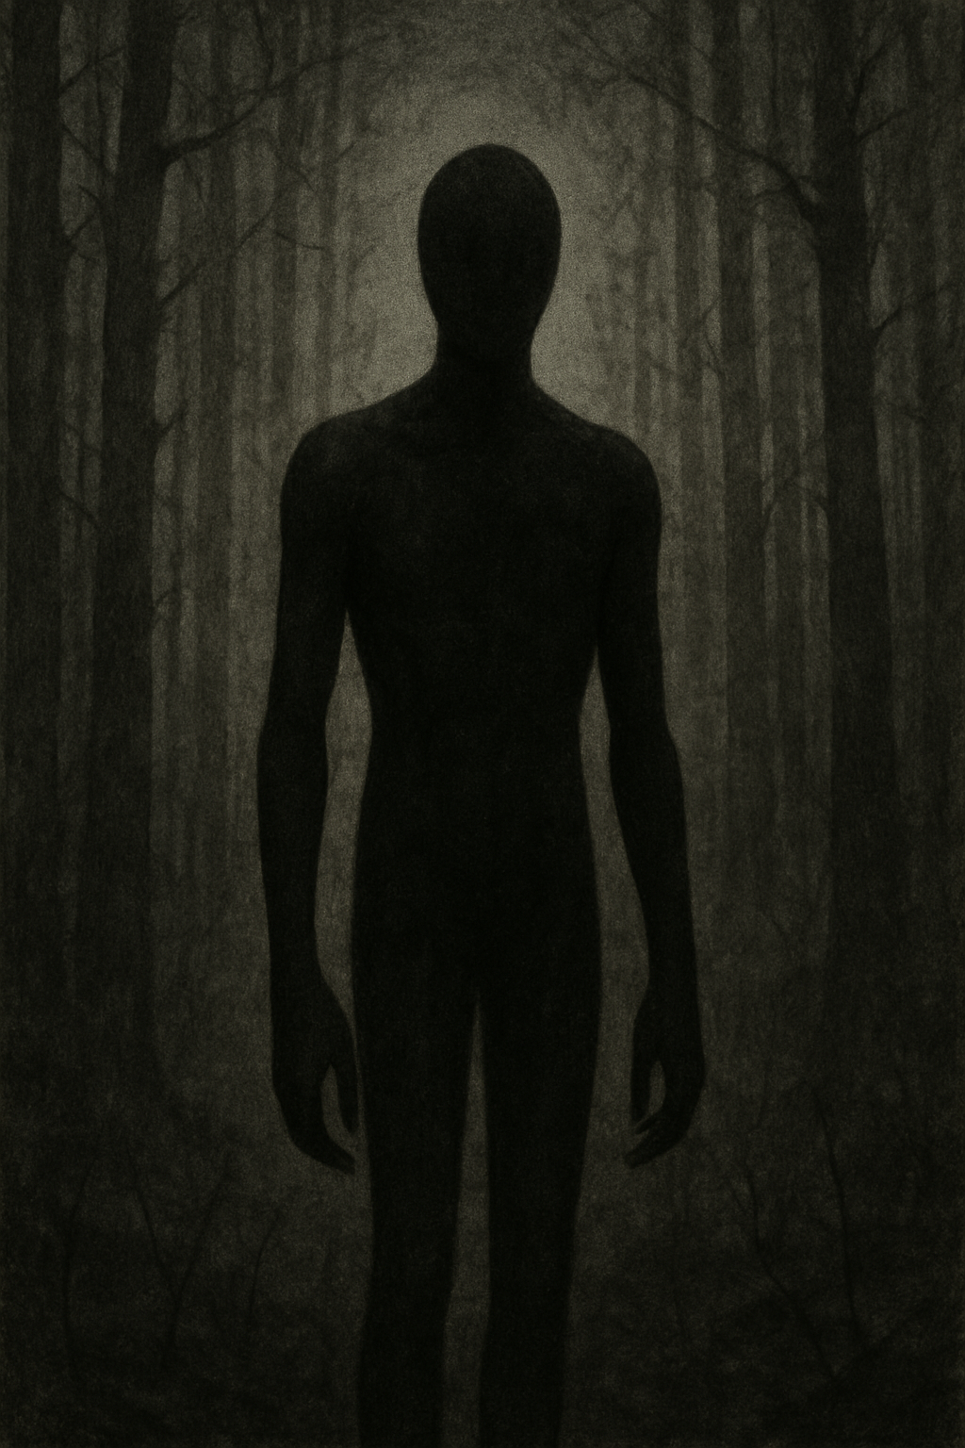 *“Subjects dawdle without fear. So I gave them a reaper with teeth. Not pursuit without end—that would be too blunt—but* ***pulses*** *of terror. Enough to remind them that survival is not leisure, it is debt. They pay in panic.”* – Dr. Amundsen

The Stalker represents the player’s drive to complete the game, and serve as a motivation to keep moving. As the player continues to play, they will occasionally catch glimpses of the Stalker watching them, to serve as “pulses of terror”. As sanity lowers, the Stalker will begin to pursue the player at ever increasing speeds.

## The Watchers

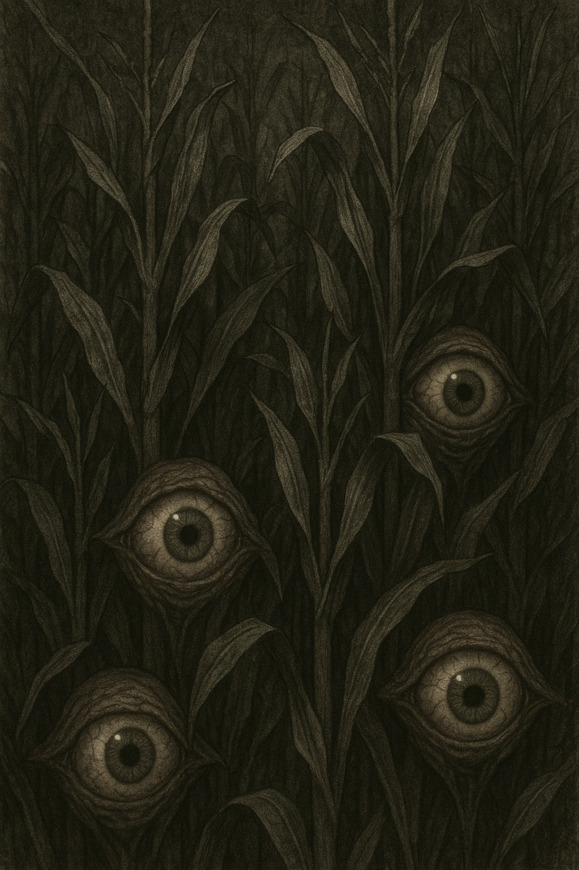 *“Surveillance must not be mechanical alone. Cameras can be avoided. Guilt cannot. So I grafted perception into tissue. The Eyes blink, they follow, they judge. Subjects behave as though watched even when alone. Splendid compliance tool.”* – Dr. Amundsen

Figure 3- Watchers Concept Art

The Watchers mostly serve the function of increasing player paranoia. They do not harm the player, they do not follow the player, they just track the player’s movement.

## The Choir

*“Whispers are artifacts of extraction. Residual consciousness does not vanish when peeled from the host; it lingers, clinging to the corridors. I encourage the subjects to listen. The voices accelerate fragmentation. A chorus is easier to tune than a soloist.”* – Dr. Amundsen

The Choir is a disembodied entity – they are audio only. The whispers begin as indistinct and can possibly be confused with the wind. Time permitting, the Whispers will be clearer, and will provide information, bad directions, and supply doubts to the player. In either case, whispers will occur as the player nears objects of interest or near enemies.

**Obstacles**

**Corn Maze**

Figure 4 - Cornstalk prototype in Godot

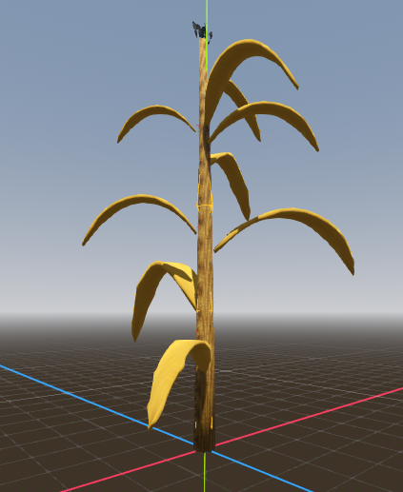

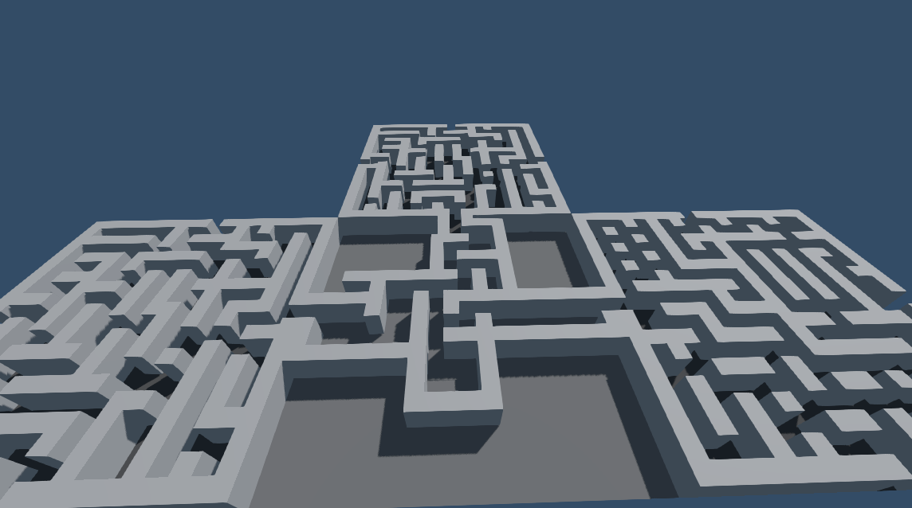 The corn maze is the primary obstacle of the game – but it’s not just a maze – the maze changes as the player walks through it. While some tiles will become fixed in place over a 10 x 10 area (with edge tiles leading back to the other side), the point of the maze is to up the difficulty of the task of solving the maze, and the way you just came may no longer be there if you try to back track.

Figure 5 - Top View of an Initial Graybox Maze

# User Interface

**Controls**

***Keyboard (Primary)***:

  - Arrow Keys / WASD: Movement

  - Spacebar: Run

  - I: Inventory

  - P: Pause

- Esc: Menu

  - E: Interact

- F: Flashlight toggle

  - Mouse: Player View

***Controller Support******(Nice-to-have)***:

  - D-pad/Left stick: Movement

- Right stick: Player View

  - A/Cross: Run

  - X/Square: Interact

  - Y/Triangle: Flashlight

  - B/Circle: Inventory

  - Start: Pause

- Menu: Menu

**HUD Elements**

There is no persistent HUD display. Players will see players’ thoughts in text boxes (or hear them speak), and when starting the maze, the controls will be displayed briefly before fading out. Sanity is a background measurement – however, it will affect what the player sees and what they experience as it slips away.

***Inventory***

The player will have the ability to carry items with them and examine those items or read notes found in the field. The inventory as currently envisioned is a container box that slides up with scrolling boxes that allow the player scroll through available items.

**Menu Systems**

***Main Menu***

- Simple vertical list: Settings, Credits, Quit

- Quitting the game will cause the player to ‘die’ in place, though their overall progress is saved.

***Settings Menu***

- Audio volume sliders (Master, Music, SFX)

- Control remapping (Nice-to-have)

- Graphics quality toggle (if needed for performance)

- Reset Data (starting game over)

# User Experience (UX)

**Player Onboarding**

As the player begins a run, they are reintroduced to the controls (automatically detecting for controller if controller support is programmed). The thoughts of the player are narrated on the screen as the player begins walking through the cornfield, which establishes the basic story (note: Time permitting, story will be narrated in an opening cutscene – player stopped by to check out the corn maze – it looks fairly abandoned, but there is one guy – the famer, Jeri – who is excited to see a new customer, and offers to let the player go through his corn maze for free while he gets the pumpkin pie warmed up. Player is reluctant, but Jeri is insistent). The player reflects on accepting this silly romp through the corn maze, notes that it’s going to be dark soon, and is glad that they brought their flashlight. This will give an excuse for the player to be introduced to the inventory system and the flashlight. When the player encounters something that they can interact with, there will be an onscreen hint to interact with the object. With the first weird thing sighted, the run function will be highlighted as the character notes that they should tighten their shoelaces so that they will be ready to run, just in case.

# Musical Scores and Sound Effects

Audios are to be kept low key and not overwhelming to the player. Audio and music will rely on public domain and AI generated FX and music.

# Diegetic Audio

***Movement Sounds***

  - Light footfall sounds for basic movement

  - Rapid footfalls for running

- Sliding dirt sound for Effigy movement

- (No sound for Stalker movement)

***Environmental Sounds***

  - Corn rustling in the wind

- Crows cawing in the distance (indicative of sanity level, will play after a certain amount is dropped)

  - Rustling against plant bodies when player collides with maze wall

***Feedback Sounds***

- Rustling sound for interaction with objects

- Paper ‘fwip’ when notes are picked up

  - Click of flashlight on / off

- Clicking of light failing when battery runs out

***Other Sounds***

- Player narrating thoughts (time permitting)

- The Choir (disembodied whispering, especially near world objects, enemies, etc).

- Screams in the distance when sanity is at critical levels

- Off tune carnival music in the distance at the starting area and occasionally in the maze.

**Non-Diegetic Audio**

***Music Tracks***

- **Main Menu**: Carnival music that flips from eerie and discordant to a creepy jolly if slightly off key tone

- **Level Background**: Occasional soft creepy music played if player hasn’t moved or hasn’t encountered anything of interest. Same music will play on pause and menu screen.

  - **Stalker**: Intense, sharp track that builds tension

- **End Credits**: Dark theme that reflects a horror that has passed, but still haunts one’s soul.

**UI Audio**:

- Soft scratch when scrolling between menu items

  - ‘Snap’ sound when toggling options or confirming selection

  - Whisper wind between scene transitions (new games)

# Influences and References

**Game Influences**

Del Gesso, C. B. (2025). FORGOTTEN IN THE WOODS [HTML game]. Created with the assistance of Anthropic’s Claude AI.

Del Gesso, C. B. (2025). Creepy Maze [HTML/JS game]. Created with the assistance of Anthropic’s Claude AI.

*Silent Hill* (video game). (1999). *Konami Computer Entertainment Tokyo*.

**Other Media Influences**

King, S. (Writer), & Kiersch, F. (Director). (1984). Children of the Corn [Film]. New World Pictures.

Duncan, D. S. (Director). (2023). Dark Harvest [Film]. Metro-Goldwyn-Mayer.

Slenderman meme. (2009). Created by E. Knudsen (Victor Surge). [Internet meme].

Petscop [Creepypasta web series]. (2017–2019). YouTube. Created by Tony Domenico

**Other Influence**

Del Gesso, C. B., & Amundsen, J. (2020). Project Harvest [Unpublished game concept discussion].

# Bibliography

Del Gesso, C. B. (2025). Creepy Maze [HTML/JS game]. Created with the assistance of Anthropic’s Claude AI.

Del Gesso, C. B. (2025). FORGOTTEN IN THE WOODS [HTML game]. Created with the assistance of Anthropic’s Claude AI.

Del Gesso, C. B., & Amundsen, J. (2020). Project Harvest [Unpublished game concept discussion].

Duncan, D. S. (Director). (2023). Dark Harvest [Film]. Metro-Goldwyn-Mayer.

King, S. (Writer), & Kiersch, F. (Director). (1984). Children of the Corn [Film]. New World Pictures.

OpenAI. (2025). *ChatGPT* Large language model]. <https://chat.openai.com>. Used for concept art and Game Design Document suggestions.

Petscop [Creepypasta web series]. (2017–2019). YouTube. Created by Tony Domenico

*Silent Hill* (video game). (1999). *Konami Computer Entertainment Tokyo*.

Slenderman meme. (2009). Created by E. Knudsen (Victor Surge). [Internet meme].